**BELOW CYLINDERS REMOVED FROM UPPER FLOOR AND INSTALLED AT 17TH FLOOR ACCORDINGLY**

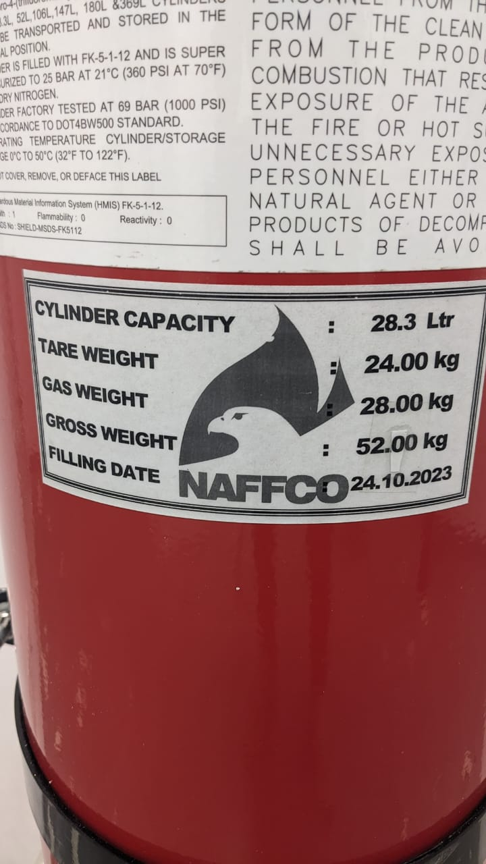

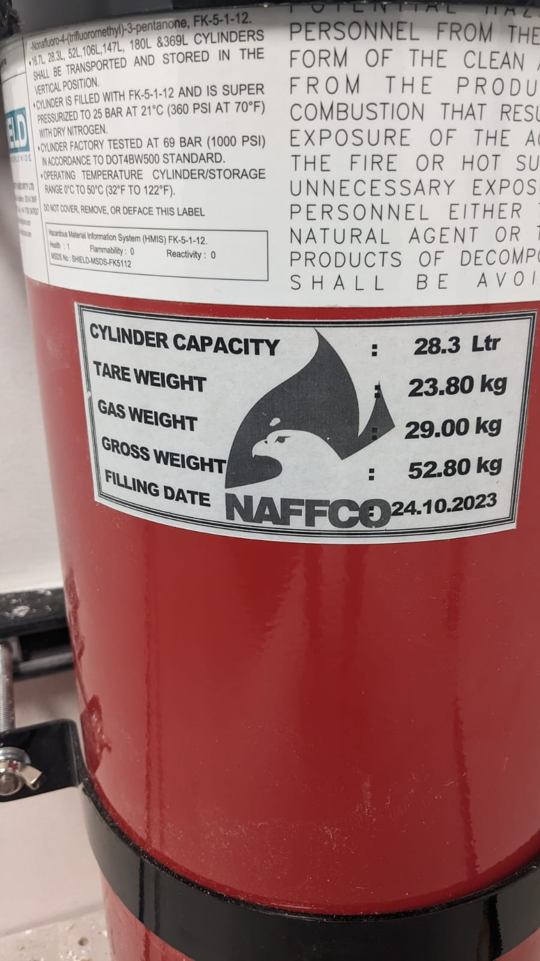

**INSTALLED AT 17TH FLOOR UPS ROOM**

**INSTALLED AT 17TH FLOOR IT ROOM**